Step 2: Integration and/or Acceptance TestingThe integration test for the REST API. Following are instructions on how to run it and how we automate this for CI/CD.

We can test with the following approaches:

* Open the code folder with IDEA 2023 Community, where unit tests and Integration tests are available in directory: src/test

At the start of the tests, schema.sql and data.sql will be executed. The customer table will be created, and it will contain six test customers for CRUD operations testing.

After the API service deployed by minikube, we can review the data stored in H2 database. Try the following H2 console link http://{your-service-ip}:{port}/h2-console/ console (no password needed) and make sure the JDBC URL is jdbc:h2:mem:testdb

# we can use the cmd line minikube service cust-api --url to get {your-service-ip}:{port}

# if launched by cmd line java –jar, the url is http://localhost:8080/h2-console/

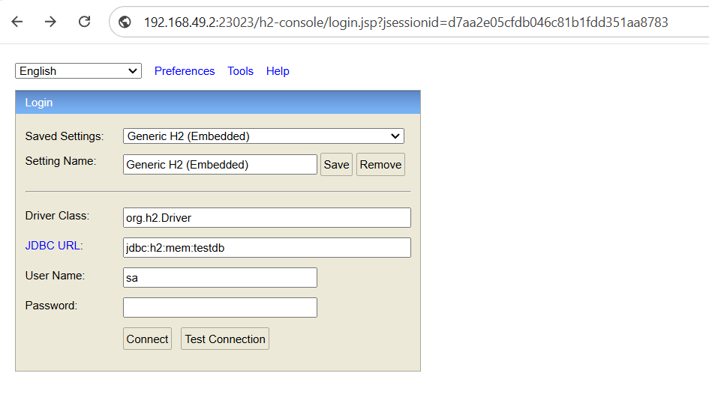

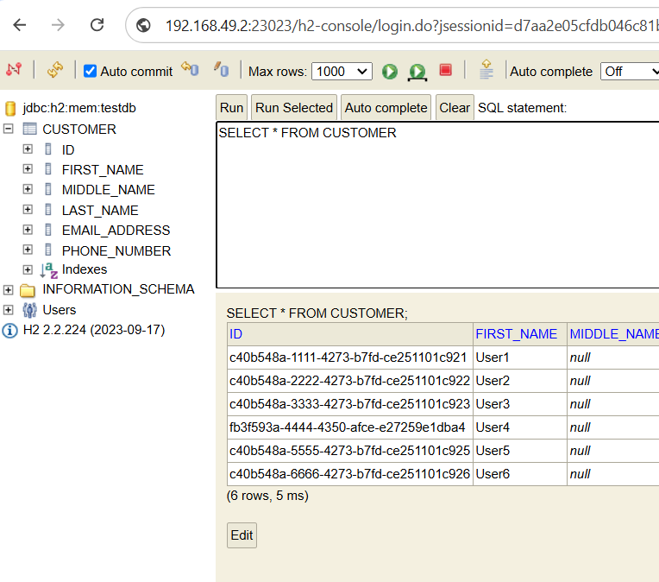

Unit tests and Integration tests are available in the src/test directory:

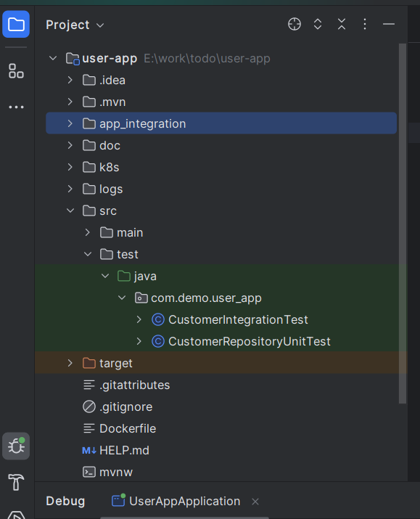

To run the two tests, we can open a terminal in the project root directory and input the commandlines:

mvn verify

* After the API service deployed with minikube, we can test it by using the linux script test.sh in folder /app_integration.

Please try with a cmd line: ./test.sh

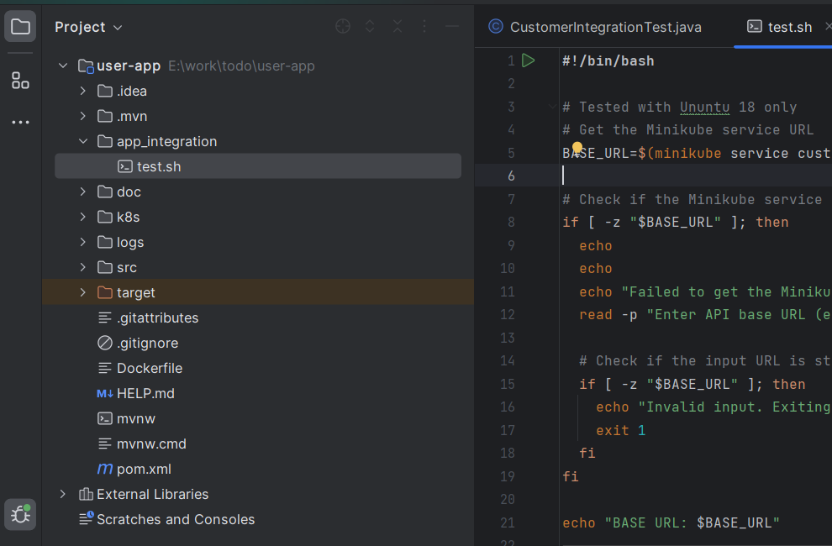

* Alternatively, we can use Chrome to test via Swagger UI, and we need to run the command line minikube service cust-api --url to query the service url. (Please copy the url to the browser address bar with the postfix /swagger-ui/index.html)

# if launched by cmd line java –jar, the url is http://localhost:8080/swagger-ui/index.html

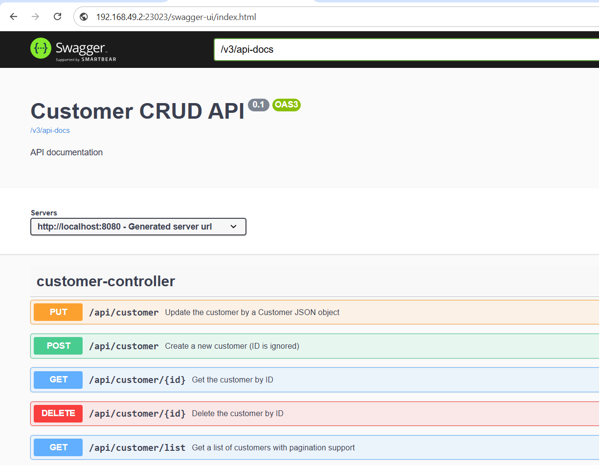

For how we automate this for CI/CD, please refer ./doc/Step 4, Step 5 and Step 6.